**

**STAFF NOMINATIONS**

Miss Hoon has nominated **Miss Roberts** this week as a thank you for all her work that she has been doing at home to create learning resources for children.

Mrs Turner would like to say a big ‘Thank You’ to **Mrs Eggleston** for her kindness, positivity and support over this last term.

**

**THOUGHT FOR THE WEEK….**

God’s will for us is to give respect to every single person. Peter’s command: ‘Fear God’, reminds us to continue to hold His power, majesty and sovereignty in awe and wonder.

**How do you show respect to those around you? Write a poem or draw a picture of what respect means to you.**

**

**STARS OF THE WEEK**

Mrs Smith has nominated **Emmanuel K** for settling into the 6S bubble so well, and **Adams** for showing improved focus.

**Splendour** in Year 1 for enjoying some gardening with dad at home, and **Eliezer** for telling Miss John about all the planets he has been learning about.

**Fejiro i**n Year 3 for making a brilliant African drum at home which he uploaded onto OneNote.

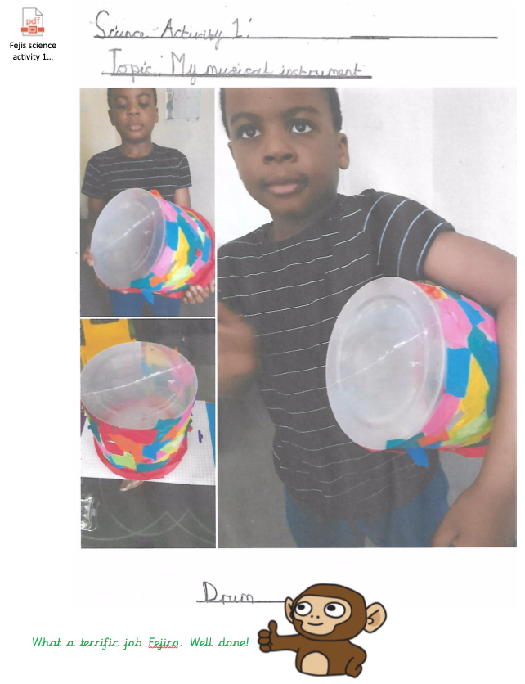

Mrs Eggleston is nominating **Iyanu, Nevaeh, Seyi and Andrew** in Reception for working really hard and completing work assigned to the online learning platforms on a daily basis. In school this week, **Joshua** has been using his words really well to ask for things.

**Habiba** in Year 4 is an absolute dream every time that she’s been in school - polite and conscientious and has followed all instructions beautifully. Well done!

Mrs Laird is nominating **Emmanuel** as a star of the week for making a big effort with the work he has been doing on Purple Mash.

**Onome and Ademide** have continued to do some art work over the holidays and as you can see here in the photos, they have created an amazing butterfly and play dough caterpillar. It cheered Mrs Turner up!

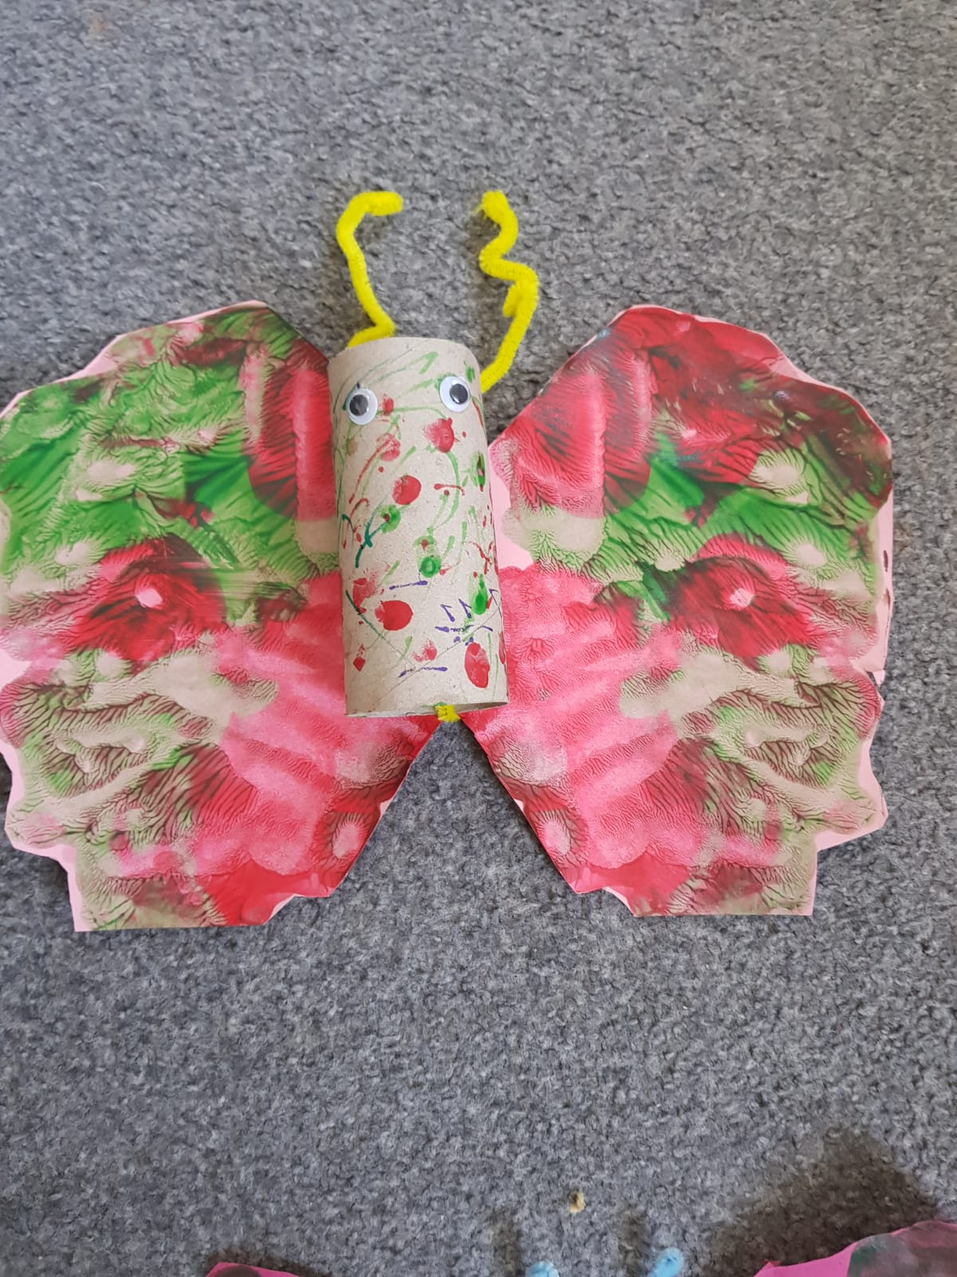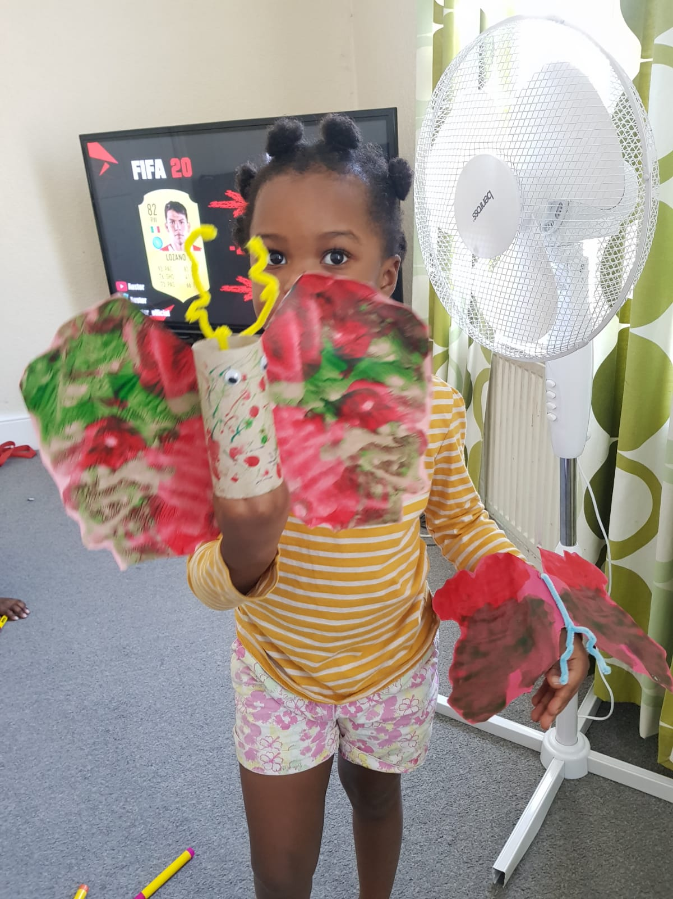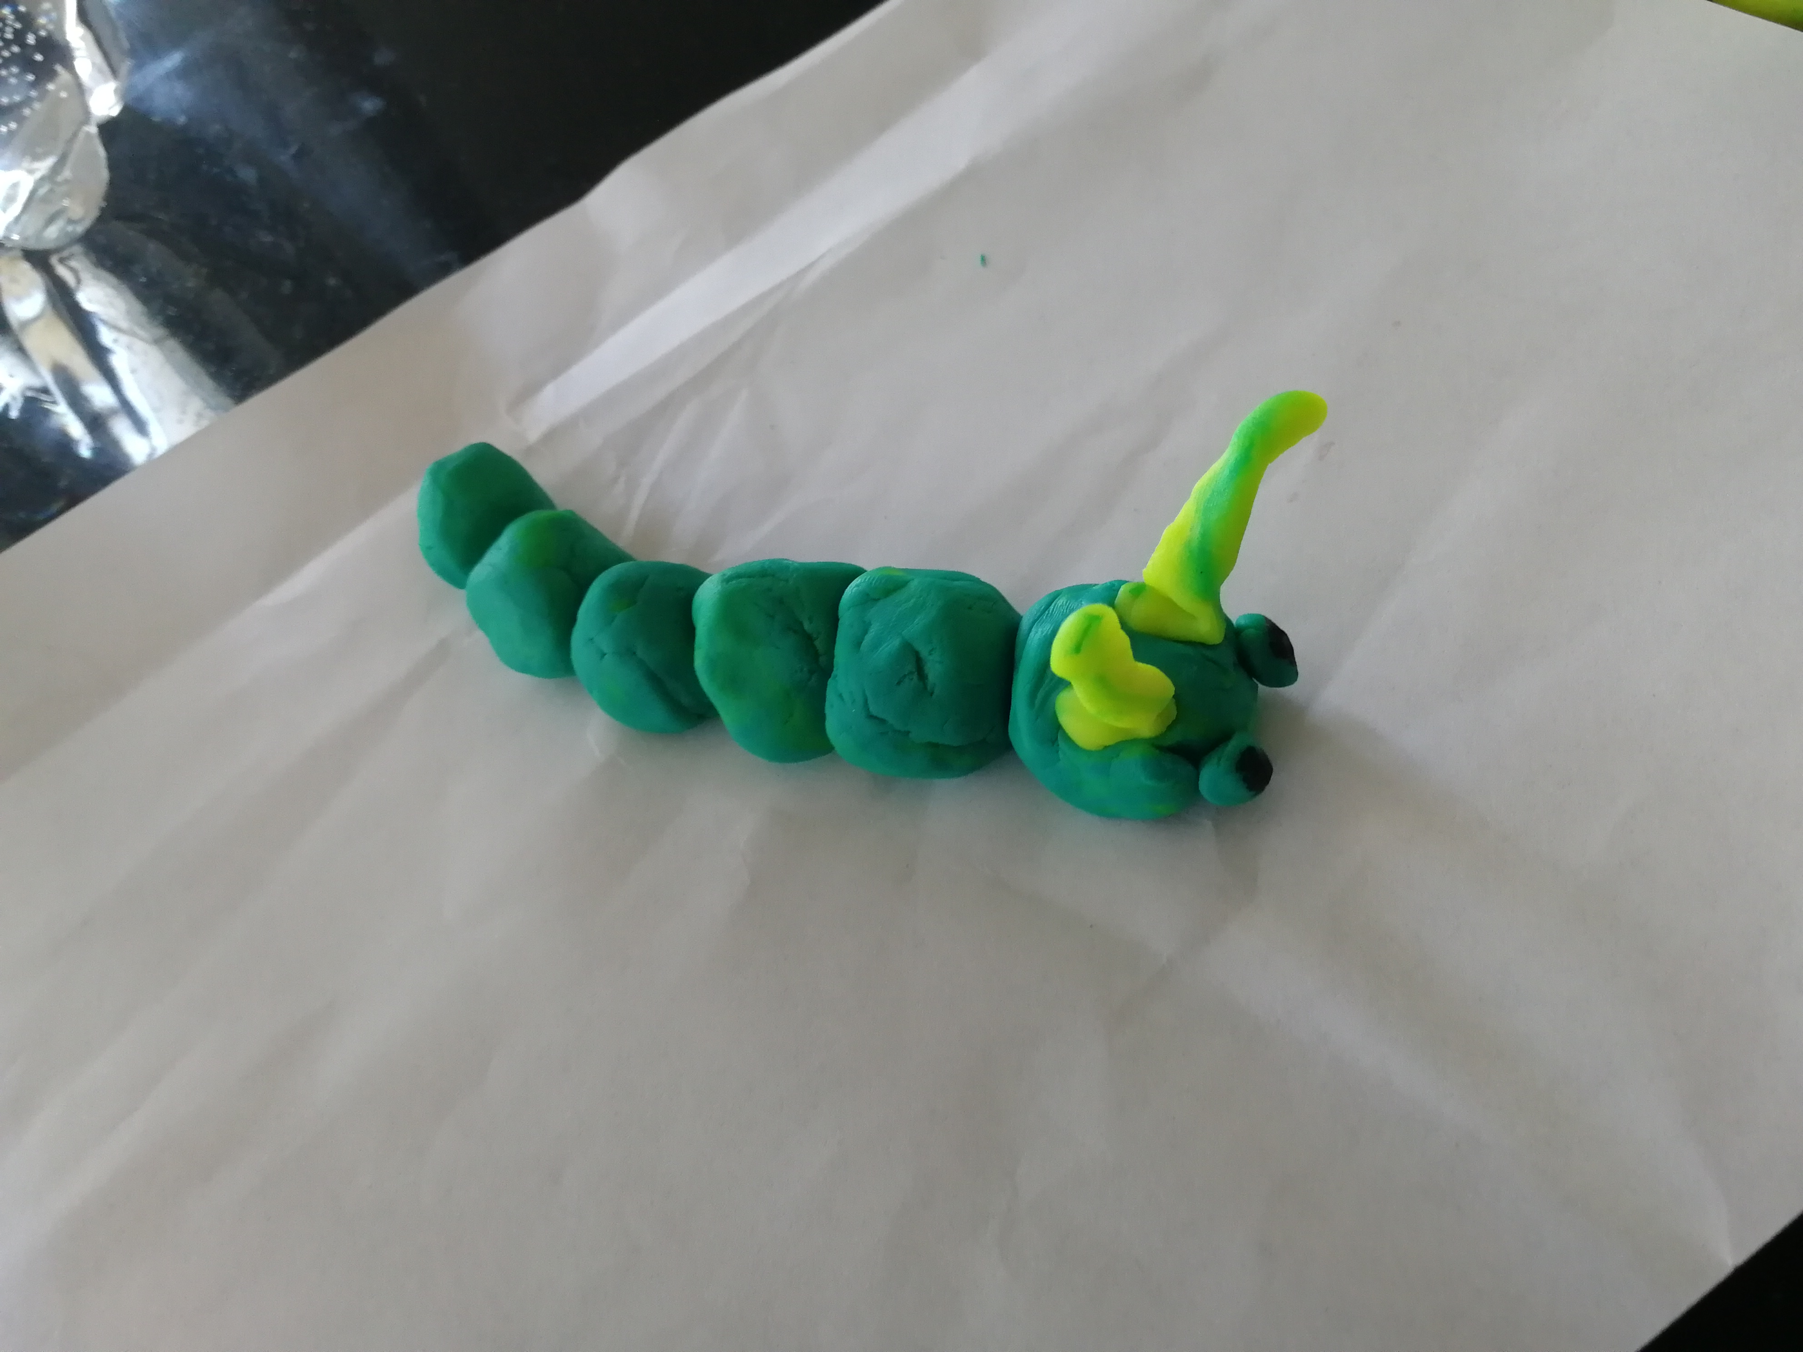

Dear Children,

This week in school as well as our children in the Hub, we have welcomed back lots of our year 6 children and they have settled into the new routines very well. They have been very sensible with social distancing but at the same time managing to have lots of fun with their friends. We are very proud of everyone.

Next week, children in Year 1 will also join us in school and we are very much looking forward to seeing them back with us.

Don’t worry if you are in a different year group because we are still thinking about you and your teachers will continue to set your online learning and will be speaking to you over the telephone.

Sending you my love and best wishes as always,

Mrs King

Mrs King



fd

**Message from our Chaplain…**

I love playing games. Maybe you could teach me your favourite when we’re all back in school sometime.

In schools this week it must have felt like the game I used to play on the computer – you have all these cars and buses in a car park and you need to move everything around one at a time to get enough space to get your car out of the car park without bumping into the others. Teachers have been moving tables and chairs around to make sure everyone can fit in and stay safe. Or I wonder if it has felt a bit like playing musical statues or musical chairs like we used to play at birthday parties. You keep moving and doing your own thing but secretly you are watching everyone else and the grown up in case the music stops and you need to find a space of your own and sit down, or freeze like stone and wait for your turn to move again.

Although things feel funny at the moment: nothing is normal, no-one is where they would normally be, and school is not going to be quite the same for a while – I’d like you to remember that playing helps us smile and give us space to think about things.  I pray that you will find space to play today. I pray that you will find time to have fun today. And when you get funny feelings – I pray that God and the Good People around you will help you feel strong again. Amen.

Don’t forget to play and pray today!

**Rev. Dominic Hubbuck**

Hello Hargreaves Class,

I hope you are all keeping well and looking after yourselves. What an odd time for us to be apart for so long, I miss you lots.

I have a very simple challenge for you this week - be the best you that you can be, there is no one better at being you. Keep smiling. I cannot wait to see your smiles again soon. 🙂

Mrs Laird



[This Photo](https://detectivemaxxzeqsterscreepycrawlyamazingadventures.wordpress.com/) by Unknown Author is licensed under [CC BY-SA-NC](https://creativecommons.org/licenses/by-nc-sa/3.0/)

Let us pray…

Dear God, please keep our families, friends and loved ones safe. Please watch over them always, and let good health, happiness and blessings befall them. Amen

Prayer by Mrs Eggleston

Dear Monet Nursery Class,

I hope you are still keeping well and safe with your families at home. It won’t be much longer before you can return to school and see your friends again. Just keep going because I am very proud of all your achievements so far-it’s fabulous! I look forward to seeing photographs of our new topic ‘Under the Sea.’ Here you can make your very own sea creature mobile by painting, collaging and modelling your favourite fish of the ocean.

God bless you all.

Love and Hugs,

Mrs Turner.

A message from Miss John,

“I am still missing you lots and lots, more every day! I know you all must miss your friends and being at school very much. But I am so pleased and impressed with the amount of work you are doing at home, and how well you have adapted to being at home this long. You are all superstars! ❤ “